How are my 21st Century skills looking this week?
Communication 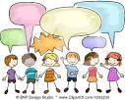 | Looking awesome! I can probably do better… I need to work on this.  M T W Th F M T W Th F M T W Th F
Collaboration | Looking awesome! I can probably do better… I need to work on this.  M T W Th F M T W Th F M T W Th F
Critical Thinking 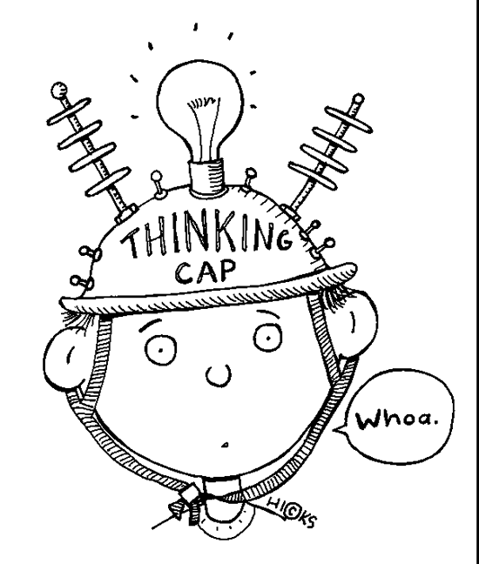 | Looking awesome! I can probably do better… I need to work on this.  M T W Th F M T W Th F M T W Th F
Creative Thinking | Looking awesome! I can probably do better… I need to work on this.  M T W Th F M T W Th F M T W Th F

